This article originally appeared in Issue 39:4 (Mar/Apr 2016) of Fanfare Magazine.

FEATURE REVIEW by David DeBoor Canfield
S. S. SMITH Notebook.¹ Magdalene.² Husbands and Wives.¹ Hawk. One for Two³ •Susan Fancher, ¹Mark Engebretson (sax); ²Sylvia Smith, ²Ayano Kataoka (perc); ³John Alexander (org) • CHEN LI 104 (63:30)

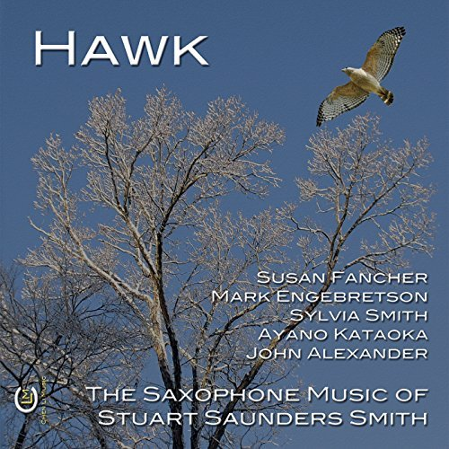
Hawk: The Saxophone Music of Stuart Saunders Smith
Audio CD; CD
Chen Li Music
I’m a bit surprised, given the numerous saxophone conferences I’ve attended, that I cannot recall having encountered the saxophone music by Stuart Saunders Smith prior to receiving this disc from Fanfare Central. Well, as they say, better late than never: These works are finely crafted and show an individual compositional voice at work. Smith has been writing music for 50 years, and has amassed a body of some 200 compositions. His philosophy of writing he sums up in the pithy statement, “My music, among other things, is a record of my self, altering.” I have to confess that even as a composer myself, I’ve never given any thought to how my music might have changed me. Perhaps it has, but that’s something I’ll think about on another day.

The recital opens with Notebook, a work scored for all four major saxes, but employing only two players. Susan Fancher switches off between the two B♭ instruments (soprano and tenor saxophones), and Mark Engebretson alternates between the E♭ instruments, the alto and baritone of the species. The work might be described as Pointillistic lyricism. The Pointillistic element predominates, and the entire work has an improvisatory feel. I found out why after I read the notes: The performers are given considerable license in numerous parameters, yielding a result in which the textures are quite busy, often giving the illusion that these two players are each performing on two instruments simultaneously, which of course they are not.

Magdalene, on the other hand, calls for a trio of soprano saxophone and two percussion, and is much less Pointillistic than its predecessor. This is not to say that there are not numerous leaps required of the saxophonist, whose lines are quite disjunctive in their motion. In this work, the saxophone has to carry all of the tonality of the piece, since the percussion is limited to the non-pitched instruments such as suspended cymbal and snare drum. Its 18-minute duration is broken into four sections (not referred to as movements); in each of them, the saxophone spins out a rather mournful line, vaguely tonal at most, although as far as I can determine, it is not a dodecaphonic work. The organizing principle in Magdalene is one of non-organization. In other words, each instrumentalist has his or her own part, with the instruction that it be played independently, and not in sync with the other two players. This device serves to prevent any sense of metrical feeling or pulse, needless to say, and rather much gives the work a timeless feeling.
Husbands and Wives is the only work on the program that calls for two of the same instrument—in this case, a pair of alto saxophones. As in the two preceding works, much liberty is given to the performers, not only in regard to melodic independence, but also in respect to phrasing and dynamics. Apparently, the players are instructed to make these choices in advance of their performance of the piece, and with no collaboration with each other. What emerges in an interesting work: Clearly the material is similar for each instrument, but one never knows what direction it will take around the next corner. All of this is meant to depict a marriage, where two individuals, each with separate personalities and ideals merges into an integrated whole, albeit one with various degrees of tension, resolution, personal discovery, etc. It’s an interesting concept, and one that might profitably be explored by other composers.

Hawk is the sole unaccompanied work on the CD, an exercise for soprano saxophone. Also, unlike the other works, parameters such as rhythm, dynamics, and phrasing are all specified. Absent the aleatoric features of the previous pieces, it’s not too surprising that this work is the most expressive and tonal on the disc. Its tonality is quite free, and falls on the ear very graciously. The work comprises several sections, including a faster section that resides mainly in the upper register of the instrument.

Closing the recital is One for Two, which is set for alto saxophone and organ. This combination seems logical given the fact that I’ve sat at the consoles of quite a few large pipe organs (which I do not play, at least in public), and can never remember seeing a saxophone stop. Consequently, a saxophone will add a color to the organ that is not otherwise present. In this work, the composer juxtaposes call-and-response figures with sections of rhythmic unison and counterpoint, and along the way calls for many avant-garde techniques, including tone clusters in the pedal, squeals in the altissimo range of the saxophone, unison writing, percussive sounds in the organ (which I have no idea how these are executed), all employed to the end of great originality. Silence is also an integral part of this work, which is probably my favorite on the disc.

I first heard Susan Fancher play (on soprano saxophone) at the 2009 World Saxophone Congress in Bangkok, where she exquisitely performed Hilary Tann’s Shakkei. As I was hearing her for the first time, I kept thinking, “Here is a major artist!” and that opinion has never wavered in all the subsequent performances of hers I’ve heard. I’ve also encountered Mark Engebretson on several occasions in live performance, and not only as a performer, but as a fine composer in his own right. He is equally impressive, and having the two here together on the same CD proves to be a real delight. Given the imaginative writing and the superb rendition of these works, it is easy to give this disc a hearty recommendation—and not only to saxophone enthusiasts. David DeBoor Canfield

